Asthma – Pathophysiology

General:

1. Asthma chronic inflammatory disorder
2. Epidemiology (Stats)
   1. 22 million has asthma (total US population 300,000,000)
   2. Highest in African
3. Etiology (cause)
   1. Childeren: 60-70%
      1. IgE allergen (atopy)
   2. Adults: 30-40%
      1. Drug trigger ing asthma Nonselective Beta blockers, NSAID, Benzochloride (plasticizer, perfume)

Pathophysiology (study of disease)

1. Treat symptom Beta 2 AGOnist
2. Treat long term use corticoid steroid (inflammation)
3. Cytokine Imbalance

Factors favoring the TH-2 phenotype

Widespread antibiotic use

Western lifestyle

Diet

Factors favoring the TH-1 phenotype

Presence of older siblings

Early exposure to daycare

TB, measles, Hepatitis A

Cytokine Balance

IAR = Immediate Asthma response LAR = Late Asthma response Chronic Asthma

FEV1

Minutes Hours Days

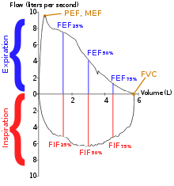Diagnosis

1. Spirometry
   1. exhale quickly into machine diagnosis
   2. Determine if
      1. Reversible
      2. Obstructive vs restrictive
2. PEFR Peak Expiratory Flow Rate
   1. Use peak flow metre
   2. MONITOR (not diagnose) measure severity